News release

Date: (Insert date of issue)

(Insert name of local area) (insert name of individual/group) (Insert snappy description of event) for World Kidney Day 2019

(Insert participant name or group/organisation) from (location) has taken up the challenge to arrange (Insert brief description of event) in (insert place where event will take place and on what date) to help raise awareness as part of World Kidney Day UK 2019.

(Insert name), is getting out into the community to raise awareness of the importance of your kidneys, how you can look after yourself and how you can reduce the risks for kidney disease.

(Name) said: “I/We decided to 'do our bit' for World Kidney Day because (insert details of why supporting WKD in this way is important to you, for example a personal connection with kidney disease). We need to raise awareness of this life-threatening problem. The more people know about kidney health, the better."

Dr. (Name – you will need to get permission and agree the quote with your local kidney doctor), a local kidney doctor, comments: "Kidney disease is common, affecting over three million people in the UK. However, it can go undetected as people often have no symptoms. People with high blood pressure, diabetes, heart disease, or have a family history of kidney disease and those from certain ethnic groups, have a higher risk of developing kidney disease. The good news is that early detection, changes in lifestyle (such as taking more exercise) and a healthy diet can often slow down the progression of the disease, delaying the possible need for dialysis or transplantation."

“Please get behind (name) and help raise awareness."

For more information about World Kidney Day in the UK and downloadable resources please visit: www.worldkidneyday.co.uk. For information on the global initiative, visit www.worldkidneyday.org

ENDS

For further info, please contact: (insert details)

Notes to Editors:
About World Kidney Day:
World Kidney Day is an annual global awareness and education event, held on the second Thursday in March. Following the 2019 theme of Kidney Health for Everyone Everywhere, the aim is to draw public attention to the importance of maintaining a healthy lifestyle to help look after your kidneys, the risks for developing kidney disease and the impact it has on patients.

The campaign in the UK is led by the Kidney Charities Together Group comprising four leading kidney charities:

Kidney Care UK www.kidneycareuk.org
Kidney Research UK www.kidneyresearchuk.org
National Kidney Federation www.kidney.org.uk
The Polycystic Kidney Disease Charity www.pkdcharity.org.uk

The 2019 World Kidney Day campaign in the UK is also supported through grants from Amgen (Europe) GmbH, Pharmacosmos UK, Renal Services UK Ltd and Vifor UK/Vifor Fresenius Medical Care Renal Pharma UK.

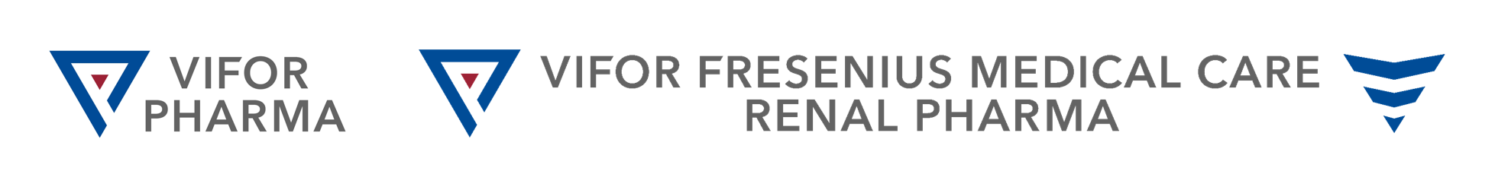

Kidney Facts:
- Kidney disease is common, can affect anyone but is treatable for some people if recognised early
- Uncontrolled diabetes and high blood pressure are the biggest causes of kidney disease
- An estimated 60,000 premature deaths occur in the UK every year due to chronic kidney disease (CKD)
- Right now about 64,000 people in the UK are being treated for kidney failure
- More women have kidney disease, yet more men start dialysis
- People from socially disadvantaged backgrounds are more likely to develop CKD, need dialysis and die with CKD.
- 4,820 people are waiting for a kidney, yet only around 3,300 transplants are carried out each year
- 3,770 people a year die while on dialysis and five people die every week while waiting for a kidney transplant
- Transplants don’t last for life – they currently last an average of 10-15 years
- People from black, Asian or minority ethnic (BAME) backgrounds are more likely to progress faster towards kidney failure
- BAME patients make up a third of the waiting list and have a longer wait for a kidney transplants; many will die waiting.

